A
Seminar Report On
“Name of Topic”

Submitted In Partial Fulfillment of the Requirement
For The Award of Degree of Bachelor of Engineering
In Civil Engineering of
North Maharashtra University, Jalgaon

Submitted By
Student Name

Under The Guidance of
Prof. Name of Guide

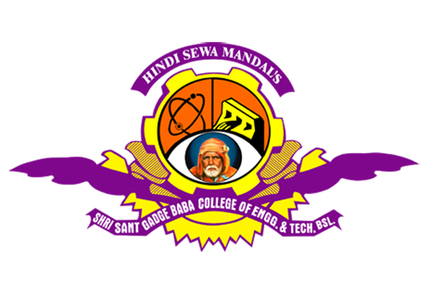

DEPARTMENT OF Civil ENGINEERING
Shri Sant Gadge Baba
College Of Engineering And Technology, Bhusawal - 425203
North Maharashtra University, Jalgaon
2014-2015
Shri Sant Gadge Baba
College of Engineering and Technology,
Bhusawal 425 203

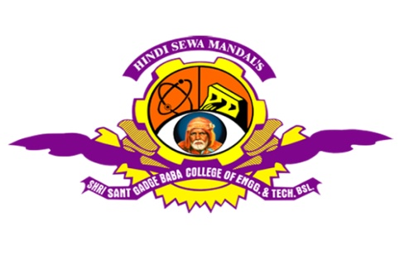

Certificate

This is to certify that Mr./Miss.____________________ has successfully completed his/her seminar on “_______________” for the partial fulfillment of the Bachelor’s Degree in the Civil Engineering as prescribed by the North Maharashtra University, Jalgaon during academic year 2014-15

Prof. Name of Guide |  | Prof. P. P. Bhangale
(Guide) |  | (H.O.D.)
SEAL
Dr. R. P. Singh
Principal

